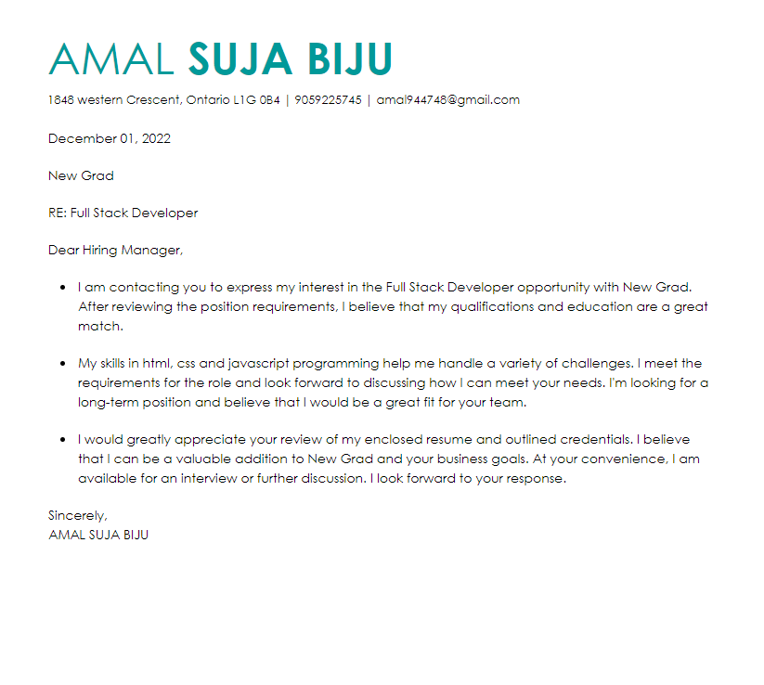

**Resume**

**AMAL SUJA BIJU**

**9059225745**

**1848 western Crescent. Oshawa, ON**

[**amal944748@gmail.com**](mailto:amal944748@gmail.com)

**Education**

September 2021-Present

Computer programming, Durham College, Oshawa, ON

Pursing the third semester of 2-year computer programming Course

Studied -web development and software testing using selenium and python, Database management, Java, C#, C++t

**Skills**

*keen knowledge of programming languages such as c#, C++, and python, C, Java, javaScript

*Proficiency in making a website using PHP and JavaScript

*Knowledge of servers and other tools like GitHub, Stack Overflow, Net framework

* Good Communication skills in English

**Experience**

**\***Worked along with a team to conduct testing of an online banking website using selenium and python

*Conducted a group project which was to make a system proposal for Durham college Phone App

* Created WPF application using .Net and MVC

*Experience in the database management system

* Experience in Framed a website using PHP, HTML, and CSS

*Currently working on JavaScript for developing a web application

**AMAL SUJA BIJU**

**9059225745**

**1848 western crescent**

[**amal944748@gmail.com**](mailto:amal944748@gmail.com)

[**https://www.linkedin.com/feed/**](https://www.linkedin.com/feed/)

**References**

**1.Jibin B samuel**

**Software developer at TCS, ON**

**9059227845**

[**jibinbsamuel@gmail.com**](mailto:jibinbsamuel@gmail.com)

**2. Bijil Biju**

**Web developer in Google**

**9058745812**

[**bijilbiju@gmail.com**](mailto:bijilbiju@gmail.com)